# 9.Smart Traffic Control

## Project Description: -

The Smart Traffic Management System is an advanced solution designed to optimize traffic flow by dynamically controlling traffic lights based on real-time conditions. It consists of four traffic lights, each with three LEDs (red, yellow, and green), to regulate vehicle movement efficiently. The system is programmed to follow a predefined sequence but can override it based on live traffic data. This ensures that vehicles do not experience unnecessary delays and traffic congestion is minimized.

A servo motor is incorporated to depict a moving car, visually representing how vehicles respond to traffic signals. The servo activates whenever a green light appears, simulating a car moving forward. This enhances the demonstration of real-world traffic dynamics and showcases the system's effectiveness in managing intersections. By integrating motion control, the system provides a clear representation of how traffic flows based on signal changes.

To further improve traffic efficiency, an ultrasonic sensor is placed behind the intersection to detect approaching vehicles. If a large volume of traffic is detected, the system prioritizes that lane, overriding the usual light sequence to reduce congestion. This adaptive control mechanism helps ensure that high-traffic areas are given preference, reducing unnecessary waiting times and improving road efficiency.

The system is controlled by an Arduino, which processes inputs from the ultrasonic sensor and manages the timing of the traffic lights and servo motor. By leveraging real-time data and automated control, the Smart Traffic Management System provides an effective solution for reducing traffic congestion, optimizing signal operation, and enhancing overall road safety.

## Apparatus: -

|  |  |  |  |
| --- | --- | --- | --- |
| **S. No** | **Name** | **Description** | **Qty** |
| 1 | Arduino | Main microcontroller | 1 |
| 2 | LED (Red) | Traffic light indication (Red) | 4 |
| 3 | LED (Yellow) | Traffic light indication (Yellow) | 4 |
| 4 | LED (Green) | Traffic light indication (Green) | 4 |
| 5 | Servo Motor | Simulates car movement | 1 |
| 6 | Ultrasonic Sensor | Detects approaching traffic | 1 |
| 7 | Resistors | Limits current for LEDs | 12 |
| 8 | Power Supply | Provides power to components | 1 |

## Connections: -

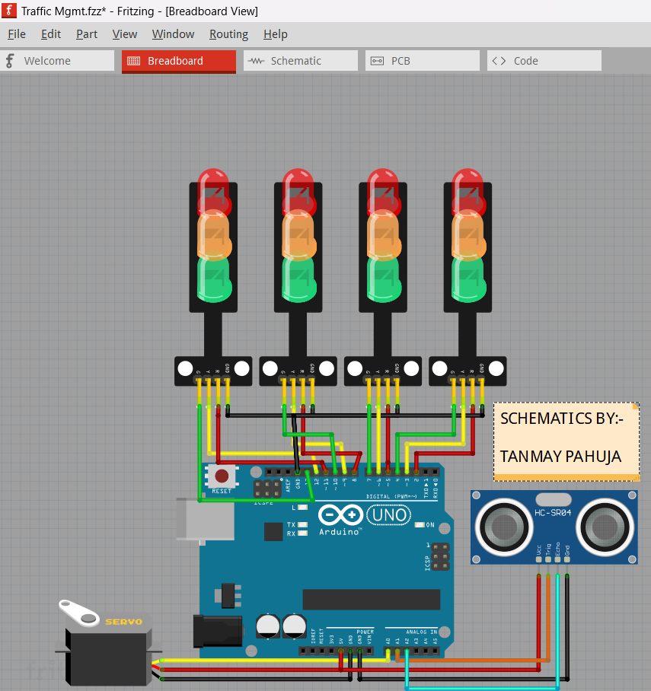

The Smart Traffic Management System connects all components to the Arduino for automated operation. Each traffic light consists of three LEDs (red, yellow, and green), which are connected to digital output pins on the Arduino. The servo motor responsible for simulating car movement is connected to another digital output pin.

An ultrasonic sensor is placed behind the traffic intersection to measure traffic density. The TRIG and ECHO pins of the ultrasonic sensor are connected to their respective GPIO pins on the Arduino. If traffic density is high, the Arduino overrides the normal light sequence to prioritize clearing congestion.

## Code: -

#include <Servo.h>

int red1 = 2, yellow1 = 3, green1 = 4;

int red2 = 5, yellow2 = 6, green2 = 7;

int red3 = 8, yellow3 = 9, green3 = 10;

int red4 = 11, yellow4 = 12, green4 = 13;

int trigPin = A0, echoPin = A1;

Servo car;

void setup() {

  pinMode(red1, OUTPUT); pinMode(yellow1, OUTPUT); pinMode(green1, OUTPUT);

  pinMode(red2, OUTPUT); pinMode(yellow2, OUTPUT); pinMode(green2, OUTPUT);

  pinMode(red3, OUTPUT); pinMode(yellow3, OUTPUT); pinMode(green3, OUTPUT);

  pinMode(red4, OUTPUT); pinMode(yellow4, OUTPUT); pinMode(green4, OUTPUT);

  pinMode(trigPin, OUTPUT);

  pinMode(echoPin, INPUT);

  car.attach(9);

}

void loop() {

  int distance = measureDistance();

  if (distance < 20) {

    controlTraffic(1);

  } else {

    controlTraffic(0);

  }

}

int measureDistance() {

  digitalWrite(trigPin, LOW);

  delayMicroseconds(2);

  digitalWrite(trigPin, HIGH);

  delayMicroseconds(10);

  digitalWrite(trigPin, LOW);

  return pulseIn(echoPin, HIGH) * 0.034 / 2;

}

void controlTraffic(bool priority) {

  digitalWrite(red1, HIGH);

  digitalWrite(green2, HIGH);

  car.write(90);

  delay(priority ? 10000 : 5000);

  digitalWrite(green2, LOW);

  digitalWrite(yellow2, HIGH);

  delay(2000);

  digitalWrite(yellow2, LOW);

  digitalWrite(red2, HIGH);

}

## Project Outcome: -

* **Dynamic Traffic Control:** The system efficiently controls traffic lights based on a predefined sequence while also adapting to real-time traffic density using an ultrasonic sensor.
* **Realistic Vehicle Movement Simulation:** The servo motor moves the car forward whenever a green light appears, visually demonstrating traffic flow in response to signals.
* **Traffic Congestion Management:** If a significant number of vehicles are detected, the system prioritizes clearing that lane to improve efficiency and minimize delays.
* **Automation & Smart Control:** Using an Arduino, the system automates signal management and optimizes traffic movement, reducing manual intervention and improving overall road safety.
* **Scalability & Real-World Applications:** The project serves as a prototype for real-world traffic management systems, demonstrating how smart intersections can be implemented to improve urban traffic flow.